Aspects of the Foot
- Planter: base of the foot
- Dorsal: top of the foot
- Medial: middle aspect of foot (closest to greater toe)
- Lateral: outer aspect of foot (closest to 5th toe)
- Proximal: closest portion of the foot to the ankle joint
- Distal: farthest portion of the foot to the ankle joint (farthest point being to end of the toes)
Bones of the Foot
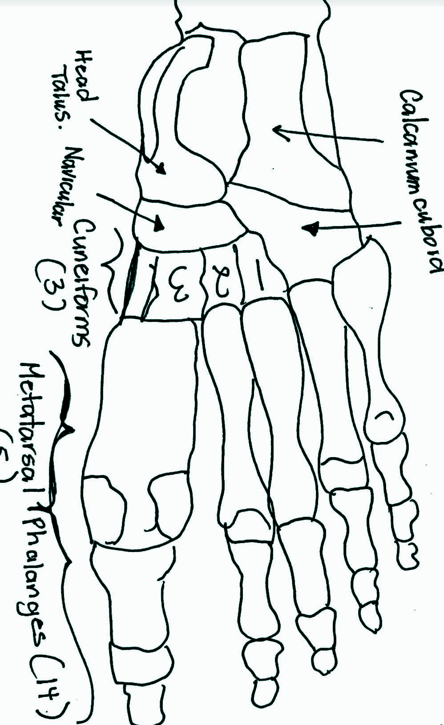
Structure of the Foot
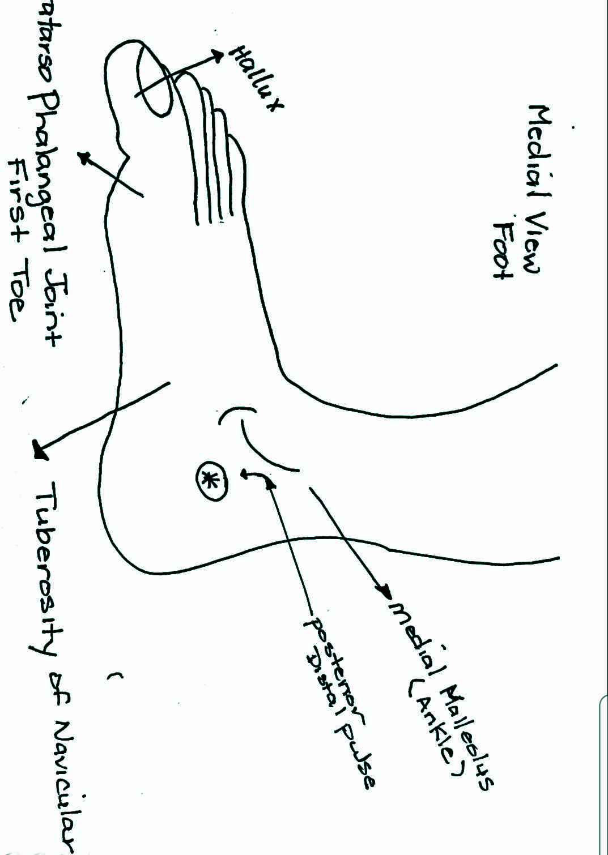
Terms of the Toes
- Hallux: another word for the greater/first toe
- Digit: term used in lieu of toe
- Metatarsals/Phalanges: when referring to the bones of the toes (see previous slide)
Labelling the Nail
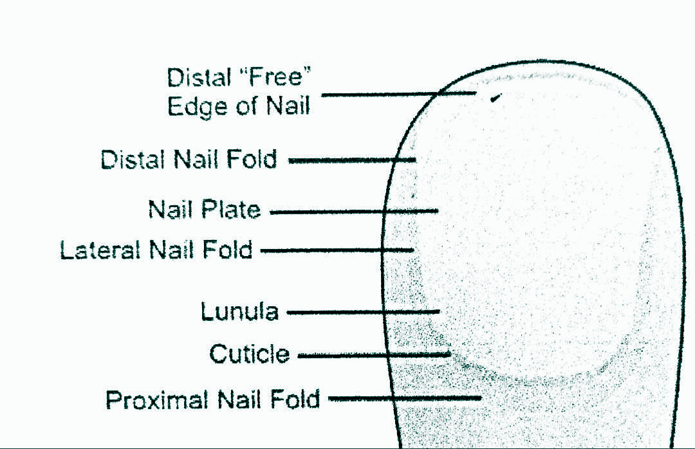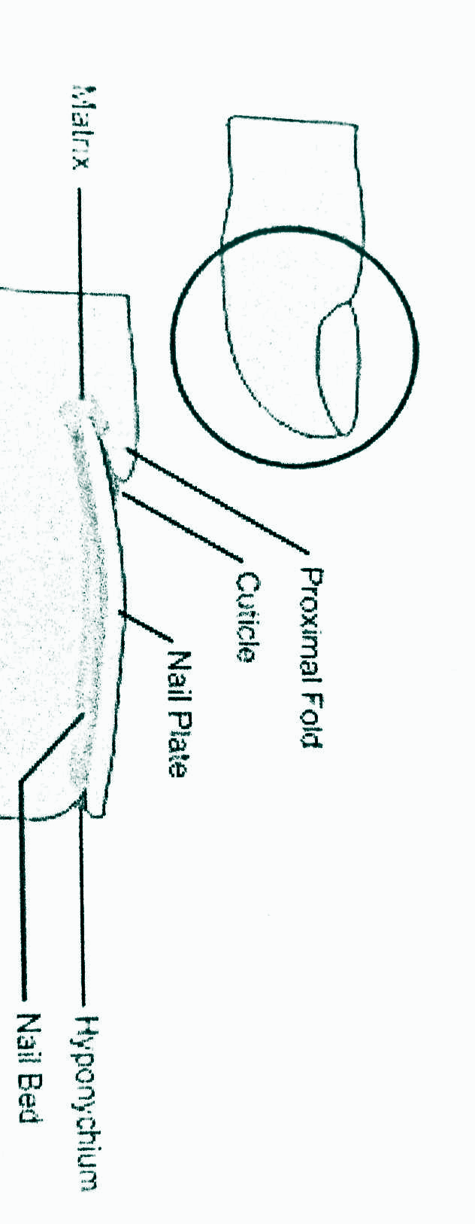
Do’s and Don'ts of Foot Care
DO…
- Wear wool/cotton blend socks
- Inspect feet weekly (daily if diabetic)
- Change socks daily or as dampness arises
- Cut nails straight across
- Wear appropriate shoes

DON’T…
- Soak for any longer than 15 minutes
- Use powder on feet as it causes bacteria to grow by keeping moisture in
- Wear socks with lycra as it holds moisture close to the skin
- Wear nylon/anything that doesn’t allow for good circulation
- Apply lotion between digits
- Overfile a callous
- Wear pointed toed shoes/heels/sandals
- NEVER work on a patient with open ulcers or PVD.

Appropriate Footwear

When fitting a shoe, there are a multiple factors to consider including:
- A toe box wider than the heel of the shoe
- An appropriate width to accommodate all digits, as well as any protruding areas (if this is a factor, consider recommending an elasticized shoe to accommodate)
- A heel that fits comfortably, but not too tight
When considering these factors, remember a shoe needs to support the width, structure and impairments of the foot.
Health Teaching
Although we can provide care on-site, care goes beyond the doors of our facility. Health teaching plays an important role in the services provided as an advanced foot care nurse.
General recommendations for the client include…
- The importance of age appropriate, properly fitted shoes
- Caring for, cleansing and drying between the digits & feet
- Monitoring the nails, structure & circulation of the feet

Diabetes
Diabetic patients are at high risk for developing foot conditions as a result of their poor circulation, neuropathy, and prolonged healing time. ALWAYS ensure you are aware of who your diabetic clients are. Diabetics need to inspect their feet on a daily basis. A helpful recommendation for your client is to place a mirror on their bathroom floor. Have your client inspect the plantar aspect of their foot every morning and/or night.
Peripheral Vascular Disease
PVD is as a result of narrowed arteries resulting in a diminished blood flow to the lower legs and feet. This can lead to pain in the lower legs, also known as claudication. The loss of blood flow to the feet can prevent wounds and/or ulcers from obtaining the oxygen and nutrients needed to heal. Therefore, allowing the open areas to grow and spread. Often, when left uncared for, this can lead to gangrene requiring amputation. UNDER NO CIRCUMSTANCES should a foot care nurse ever provide care to a patient with peripheral vascular disease.

Aging Feet
- Poor circulation: Lack of blood supply can result in a lack of sensation to the feet, putting clients at a high risk for injury. Elderly often develop atherosclerosis or become bedridden as a result. Poor circulation will also prolong healing time to the extremities. As a result, conditions to the feet and nails (i.e. fungal nails, ulcers) become more difficult to manage and/or heal. When observing the client's feet, always make sure to assess temperature, pedal pulses, capillary refill, and colouring. If the feet are extremely discoloured (dark blue/black), care will be withheld to ensure the safety of the client.
- Overweight: Additional pressure to the feet can result in open areas, callusing and/or discomfort. Decreased physical exercise & movement can lead to muscle degeneration. The development of type 2 diabetes can result, leading to further complications.
- Underweight: Decreased fat tissue can lead to bony prominences that are prone to additional friction and pressure, resulting in either callusing/corns or open areas. Poor nutrition will also act to prolong healing time (i.e. low calcium can lead to fractures).
- Structural Changes: Changes to the shape/structure can occur due to years of pressure to the feet, whether that is as a result of fluctuation in weight, ill fitting shoes, illness or other health concerns. Loss of bone density resulting in foot atrophy. Decreased range of motion and/or contraction of the muscles can lead to injuries including falls, sprains, and fractures. Fallen arches & heel spurs over the bone can lead to plantar fasciitis (inflammation of the planter muscle).
- High risk for injury: Elderly clients are more susceptible to injury versus that of other populations due to…poor eyesight, memory loss/cognitive impairments, and neglect.
- Multiple Medications: Medication plays a major role in foot health, including pharmaceutical, over-the-counter, vitamins, naturopathic therapies, and so on. Things to consider include the medicinal effect on circulation, bone & muscle health, neurovascular function, cognitive function, and tissue growth & healing.
Stages of Care
- Introduce Yourself: Prior to care, introduce yourself to the client and ongoing communication throughout care. Take the opportunity to provide additional information throughout care and health teach as needed.
- Position the Client: Clinic (Using a mechanical health grade chair, with an attached tub, in a clinical setting is a great way to ensure your client is comfortable & the foot care nurse maintains effective body mechanics.) OR Long Term Care (Utilizing the tilt option on a resident’s chair is an effective way to ensure your client’s feet are positioned upward, to avoid their feet resting on your lap and to optimize your resident’s comfort. If resident is in bed, position their feet on the side of the bed when possible while they are in a lying position. When caring for the elderly population, modifications to positioning will vary depending on the physical and mental tolerance of the resident.)
- Inspect the Feet: After removing the client’s socks, inspect the feet and nails. Make note of any wounds and/or dressing and ensure to avoid these areas during care. At this time, ask the client if they have any specific concerns and/pain to the feet and nails.
- Cleanse the Feet: Clinic (If you own a mechanical grade chair, with an attached tub, soaking the feet in warm water for 5 minutes with Epsom salts is an option. Once the feet have soaked, ensure to dry the feet, remembering to dry between the toes. Follow ministry standards to clean the tub between clients.) OR Long Term Care (If a mechanical chair is not financially available or you are providing care in a long term care setting, using a foot cleansing product to wash the feet is recommended. As stated above, ensure to dry to feet after.)
- Apply Tea Tree Oil: Although this is not required, the use of diluted tea tree oil during care will act to benefit both the care provider and client. Ask about any known allergies to essential oils before applying. Applying diluted tea tree oil to the nails will soften them, making it easier to trim thick hard nails. Tea tree oil also has may benefits for the feet and nails, including its antibacterial and antifungal properties. When using any essential oils, ensure the oil is not applied neat to the skin. Dilute your essential oils in a carrier oil, such as sunflower oil.
- Trim the Nail Horizontally: When trimming the nail, use your nippers trim straight across and refrain from curving the nail, as this encourages ingrown nails to grow. Trim the nail’s length down, but do not trim too short, as this too can lead to ingrown nails. Use the “Rule of Thumb” to guide how long to trim the nail. Place your thumb on the distal edge of the toe and ensure the nail just touches your finger. See the image provided on the following slide.
- Trim the Nail Vertically: Once the nails have been trimmed straight across, remove any corners embedded in the skin. When removing the nail, only removed half way down to avoid any bleeds and/or infection. Utilizing your black file to feel for these corners is a great resource. Ensure you are not pushing debris down into the nail while using this tool. Do so by feeling for the nail with an upward pulling motion. This motion can also be utilized along the side of the nail, once the corners have been removed, to smooth them out what nail remains.
- File the Nail: Once all trimming has been completed, use your Dremel and burr to file the nail. Work horizontally, as you file and smooth the distal end of the nail. Ensure your hand is anchored to the foot, so that your file does not slide off the nail and damage the skin.
- Care to Dry Skin, Corns, and Callousing: If corns are present anywhere on the foot, provide the appropriate care at this time. Further information will be provided in unit 4. If dry skin and/or callusing is present, use your Dremel with a mandrel stick and sand disk, to reduce any unwanted dry skin and/or callusing to the foot.
- Apply Lotion: Once care has been completed, apply lotion to the feet. Do not put lotion between the toes, as moisture is easily trapped in this area. Whether the client has care provided in the clinical and long term care setting, place their socks and shoes on their feet for them (unless you determine they can do so safely for themselves) to ensure they do not fall as the lotion will make for a slippery surface.
- After Care: Escort the client out of the room. After care has been completed, utilize your time between clients to ensure the room is cleaned and prepared for the next client. Also, complete charting at this time.
Conditions of the Foot
- Athletes Foot (Tinea Pedus):
  - Causes: Fungus attacking the tissue, commonly found between the digits, direct contact is required to pass on (very unlikely to occur in communal areas), contracted by the host due to constant heat and moisture to the area
  - Signs & Symptoms: Dry, itchy, inflamed, blistered/peeling tissue, easily irritated by anything applied to area that is not meant to treat condition
  - Treatment: A/F mimics psoriasis & eczema, so it is easily misdiagnosed, changing socks, keep area dry, wash with mild soap & warm water daily, ventilate feet, antiperspirant will help decrease moisture to area, fungicidal (over the counter or prescription), foot powder or cornstarch dusted over soles of feet/between digits, physician may recommend antibiotics to prevent further trauma
- Odouring Foot (Bromhidrosis of the Foot):
  - Causes: Excessive moisture, perspiration resulting in a breeding ground for bacteria
  - Signs & Symptoms: odouring/smelly feet
  - Treatment: Wash feet daily with antibacterial soap, deodorant/antiperspirant on soles of feet to prevent odour and moisture build up, insoles of shoes should be removed and air dried, wool/cotton blend socks, NOT nylon or lycra, socks, ted stockings, and/or elasticized stockings should be washed daily
- Hot Foot Syndrome (Pseudomonas):
  - Cause: Bacterial infection (dangerous if spread through the bloodstream, resulting in septicemia), all individuals have these forms of bacteria
  - Signs & Symptoms: Serious infection results in high fever, chills, shock, often accompanied by swimmer’s ear and/or hot tub rash
  - Treatment: is difficult as this form of bacteria is resistant to many antibiotics, patients with a weakened immune system, diabetic patients with ulcers, and burn victims are at higher risk for infection to overrun system
- Autoimmune Chronic Foot Condition (Psoriasis):
  - Causes: Different forms, but most common is plaques (raised red patches on skin covered by a layer of dead skin), smoking can trigger it
  - Signs & Symptoms: soles of feet become dry and crack, very severe forms can form pustules/pockets of pus
  - Treatment: Quit smoking, comfortable shoes with natural fibres, avoid injury to area, soak feet in warm water, dry feet well, moisturize with petroleum jelly, topical steroids, ultraviolet light treatment to slow down skin cell growth
- Hypertrophy of Stratum Corneum (Callousing):
  - Causes: Hypertrophy of stratum corneum/top layer of tissue, ill fitting shoes related to width of shoe or toe box, density of shoe, and/or support for mobility, frictional force, bony prominences
  - Signs & Symptoms; Thickening of the skin, yellowish/brown, surrounding inflammation, development of fissures to area can impede sensitive nerve tissue
  - Treatment: Change footwear, educate how to alleviate pressure areas, light filing, careful use of callus removing lotion, NEVER remove entire callus, as it will grow back thicker, apply moisture therapy daily to keep the area soft
- Hard Corns:
  - Cause: Localized hypertrophy of outer layer of tissue with densely packed center/nucleus due to constant pressure or friction to bony prominence or moving joint (i.e. plantar, metatarsal phalangeal joints, plantar aspects of heel, dorsal of all inner phalangeal joints)
  - Signs & Symptoms: Appears yellow/brown with whitish coloured center, pain, redness, callusing
  - Treatment: Light filing of surrounding callusing, removal of nucleus, proper shoes, light dressing or bandage to temporarily keep pressure away
- Soft Corns:
  - Cause: Two bones causing friction to each other
  - Signs & Symptoms: Appears yellow/brown with a white coloured center, pain, redness, soft raw tissue
  - Treatment: Decrease pressure and friction to area to allow for healing, lightly file the area, but nothing further as infection can arise
- Seeds:
  - Cause: Almost always found on the plantar surface of foot, typically between two bones
  - Signs & Symptoms: Appears yellow/brown with whitish coloured center, pain, redness, hard area in center/core of callusing
  - Treatment: Removal of seed with a curette superficially across the surface of the skin, NEVER go deep as it could result in a bleed
- Buions (Hallux Valgus):
  - Cause: Enlarged joint due to a bone shift of 15 to 20 degrees, digits grow toward each other causing a bone to protrude, hereditary, ill fitting shoes, disease process such as arthritis, neuromuscular disease, or decreased balance
  - Signs & Symptoms: Pain, redness to area, inflammation to area
  - Treatment: Proper fitting shoes (avoid footwear with a heel), select shoes with a wide toe box, surgery, anti-inflammatory medications, ultrasound technology
- Hammer Toes:
  - Cause: Ill fitting shoes, shortening of the tendons
  - Signs & Symptoms: Deformed toe, joint is raised, high risk for dorsal pressure, ulcers, corns and/or callus
  - Treatment: Padding, strapping to area if monitored, surgery in severe cases, as the procedure has a high risk for infection, elasticized toe box, deep toe box, exercising digit regularly
- Warts:
  - Cause: Contagious, transmitted via direct contact or surface areas, plantar warts (verrucas) are most common, communal areas
  - Signs & Symptoms: Painful to bear weight, pressure around area, dark center (which is the blood vessel that feeds it) under numerous layers to tissue
  - Treatment: Wear shoes/sandals in public areas, change socks daily, check feet periodically, keep feet clean & dry, over the counter products are not recommend, as they tend to burn surrounding healthy tissue, liquid nitrogen
- Morton’s Toe:
  - Cause: Hereditary
  - Signs & Symptoms: Second digit is longer than the greater toe, toe is at risk for increased pressure & sensitivity
  - Treatment: Orthotics, metatarsal padding to alleviate pressure
Conditions of the Nail
- Ingrown Nails (Onychocryptosis):
  - Cause: Clipping nails too short, pressure/injury to area, hereditary, foot structure, cail is growing towards/under tissue, commonly on big toe
  - Signs & Symptoms: Redness, pressure, inflammation, rawness, drainage, discomfort/pain
  - Treatment: Cut nails straight across and remove any embedded nails, proper footwear, wash area with mild soapy water daily, if infected soak in warm water with sea salt or Epsom salts, in severe cases anaesthetic is used/nail is removed at root by a physician
- Fungal Nails:
  - Cause: Commonly occurring from a dermatophyte fungus, yeast or mold, wearing shoes/socks that hinder ventilation, promote humid moist environments, going barefoot in communal area, greater risk if you are...older, male, have athlete's foot, diabetes, poor circulation, weak immune system, children, and/or down syndrome,
  - Signs & Symptoms: Thickened nails, brittle/crumbly, ragged/distorted shape, no shine, debris under the nail, foul odour, pain to the toes
  - Treatment: Over the counter antifungal nail creams/ointments/gels, trim & thin the nails (this reduces pressure/pain to the area and allows for deeper absorption of antifungal products), soften with tea tree oil prior to care
- Hematoma of the Nail:
  - Cause: Traumatic injury (i.e. stubbing toe), increased pressure to the toes break down the blood vessels, resulting in leakage in the space below the nail
  - Signs & Symptoms: Blood or fluid collection under the nail, red, tender, nail lifting off toe, discoloration varying from red to purple to brown/black
  - Treatment: Rest, ice, elevation, compression of toe
- Nail Cancer (Melanoma of the Nail):
  - Types: Subungual (originates from matrix), ungual (from under the nail plate), periungual (from skin beside the nail plate)
  - Signs & Symptoms: Subungual starts as a black band visible along the length of nail (melanonychia), overtime the band becomes wider (especially at proximal end/cuticle), irregular colouring, development of ulcer or nodule or bleed, nail dystrophy
  - Treatment: Consult a doctor
- Nail Atrophy (Onychatrophia)
  - Cause: Damage to matrix, internal diseases, fungal or bacterial nail infection, skin disease, psoriasis, lichen planus
  - Signs & Symptoms: Falling away of nail, loss of shine, shrinking of the nail, distorted shape, pus, discolouration
  - Treatment: Consult with professional (may be underlying disease), treat the cause
- Infection of Skin around the Nail (Paronychia):
  - Cause: Bacteria or Candida, spending a lot of time in water, injury, poor breathing footwear
  - Signs & Symptoms: Swollen, tender, fever, abscess
  - Treatment: Antibiotics or antifungal medication, keep feet dry & clean
- Thick Overgrown Nails (Onychuaxis)
  - Cause: Diabetes, improper footwear, injury to nail, circulatory issues
  - Signs & Symptoms: May appear yellow/crumbly, difficult to trim
  - Treatment: Trim nail to size consistently/as able, in extreme cases partial or complete removal of affected nail may be required
- Ram’s Horn Nail (Onychogryphosis)
  - Cause: Chronic neglect (therefore, common among the elderly), pressure to the nail over extended periods of time resulting in irregular curvature
  - Signs & Symptoms: Thickened/curved nail, yellow-brown colour, no longer flat, nail can eventually grow into skin causing pain, inflammation & potential bacterial infection
  - Treatment: Trim down and reshape as able, doctor removes the toenail (called avulsion)
- Peeling Nail:
  - Cause: Trauma, damage, prolonged water exposure can dry out the nail, pressure to the nail, picking/peeling off nail polish, applying false/acrylic nails
- Vertical Ridges in Nails:
  - Natural process of aging, common among healthy women/men, dryness (lack of moisture to ridges), trauma (typically will heal with time)
Techniques of Care
Filing: Utilizing a foot paddle or sandisk (with the use of a dremel) to maintain and/or treat conditions such as callusing, corns and dry skin to the foot is common among foot care nurses. Clients can participate in care when at home, by purchasing and using a foot paddle at home with guidance and health teaching provided.
Currette Care: When using a currette, ensure to move across the surface of the skin superficially. Do not dig into the skin deep, as this may lead to bleeds and/or infection. When not using the currette for care, keep the equipment away from children and elderly, as the equipment is very sharp. Once care is complete, dispose of the currette in a sharps container.
Trimming: When trimming the nail always trim straight across. Refrain from curving the nail, as this will promote ingrowns and irregular nail growth. When removing ingrowns, turn the knippers vertically and remove the embedded nail approximately half way down the nail. Avoid removing any further, as this is beyond our field of vision and can lead to complications (i.e. bleeds, infection).
Tea Tree Oil: Has antibacterial and antifungal properties (used on the foot and nail to oppose any bacteria and/or fungus present, including conditions such as fungal nails and athlete's foot). If a bleed were to occur when removing an ingrown corner, placing tea tree oil (packed in the corner of the nail with a cotton ball...see next slide for more information) will help to prevent infection from occurring. Softening abilities of the oil, when applied to the nails, make it easier to trim rough and/or thick nails.
Cotton Balls: Cotton balls are primarily used in foot care to prevent the nail from growing into the skin. After an ingrown corner has been removed, placing a piece of cotton (with tea tree oil) in the space remaining will assist the nail to grow properly. If a nail is growing distally, into the free end of the toe, a similar technique can be utilized. Remove the nail, as able, from the skin and place a piece of cotton below the distal end of the nail.
Charting
- Developing a Blanket Statement: When providing a treatment, a similar process is provided during care, allowing you to develop a ‘blanket statement’ when charting. This will vary depending on the environment care is provided (LTC versus in the clinic), as well as any adjustments to care due to conditions and/or allergies.
Examples:
- “Feet cleansed with adasept. All nails clipped and filed. Tea tree oil and lotion applied with gentle massage. No concerns at this time, see client next visit.”
- “Feet soaked in epsom salts and warm water for 5 minutes. All nails clipped and filed. Heel lightly filed with a sandisk. Tea tree oil and lotion applied with gentle massage. No concerns at this time, see client next visit.”
- Subjective Data: Knowledge collected from the client’s point of view. All information voiced by the client and/or family members. Any facial expressions, behaviours or noises noted throughout care (i.e. client stated, “my right pinky toe has been hurting for the past week and I am not sure why.”)
Objective Data: Information observed and collected by the nurse. Anything the nurse observes/makes note of throughout care. All care provided can be charted at this time. Recommendations made by the nurse. (i.e. refer to the ‘blanket statement’ previously discussed.)
- Assessing the Client: All medical assessments can be documented at this time, including…Identification of any conditions: fungal nails, athlete's foot, etc (note that as a nurse we are NOT allowed to diagnose. Therefore, all conditions are to be followed by ‘like’). Initial visits will have additional assessments including the presence of pedal pulses, capillary refill, temperature of the foot, means of ambulation/movement, footwear & how the patient tolerates care. ALWAYS chart when a bleed has occurred, inform the nurse (charting that they were informed) and discuss following up with the client
Example: Writer noted that the left hallux, 3rd and 5th nails were thick and fungal-like, thickness was reduced with a file.
- Developing a Plan: Further planning will differ from client to client, however, a plan should always be identified. Referrals required. Use of padding or cotton balls between/around the toes. The need to contact a family member for further discussion. If no concerns identified, the nurse can simply say “No concerns, see next visit”
Example: “Client’s family will be contacted to discuss arranging Q2 months visits, as the client’s nails take an extended period of time to grow.”
Complementary Therapies
A podiatrist, also known as a podiatric physician or foot & ankle surgeon, is a medical professional devoted to the treatment of disorders associated with the foot, ankle, and lower extremities.They are also called a doctor of podiatric medicine or DPM. A podiatrist will have the letters DPM following their name. An older name for a podiatrist is chiropodist, which is still occasionally utilized. This service is covered by OHIP.
An orthopedist, or orthopedic surgeon, is a medical doctor. A specialist in orthopedics is a doctor who specializes in the branch of medicine concerned with the correction or prevention of deformities, disorders, or injuries of the skeleton and associated structures.
A reflexologist is an alternative medical practice involving the application of pressure to specific points on the feet, ears, and/or hands. This is done using specific thumb, finger, and hand massaging techniques without the use of oil or lotion. It is based on a pseudoscientific system of zones and reflex areas that reflect an image of the body on the feet, ears and hands. As a result, such work can initiate physical changes to the related areas of the body.
Nail care specialists, nail technicians, or more informally referred to as manicurists & pedicurists, are experts in the business of nails. Toenails, fingernails, artificial nails, decorative nails—you name it. Their skills include everything from preparing cuticles to filing to shaping the nail. As an advanced foot care nurse, remind your clients to be cautious where they receive this form of care, as certain facilities fail to follow basic health & safety protocols.
Personal Protective Equipment/PPE
During care all advanced foot care nurses need to wear gloves, a gown, an N95 mask & protective eyewear.
- Gloves: a new set of gloves are to be worn per client
- N95 masks: are to be worn at all times during care to protect yourself from constant inhalation of nail particles
- Protective eyewear: this will ensure nail pieces don’t scratch or become stuck in your eyes
- Level 3 Gown: a new gown is to be worn per client
During COVID-19, extra precautions have been put in place for the safety of you and your clients. (Please continue to regulate the most updated version of the public health standards, as it is custom to change)
- Faceshield: face shields are to be worn at all times when in contact with other individuals in the workspace.
Cleaning your Equipment
In the Clinical Environment: Gross soiled equipment should be removed immediately. If this is not possible, a pre-clean foam or gel product should be applied to the equipment. The cleaning process should include disassembly if required (follow manufacturers instructions), sorting and soaking, physical removal of soil, rinsing, drying, physical inspection, lubrication, and packaging.
In the Long Term Care Environment: If pre-cleaning can not be conducted, a pre-clean foam or gel product shall be used to keep equipment moist and prevent organic matter from drying. This equipment needs to be stored in a puncture proof sealed container for transport to your designated reprocessing area.
Reprocessing of Equipment
The reprocessing area shall include a dedicated sink with clean and sterile storage areas, physically separated from the client care area. There shall be a one way work flow from decontamination to disinfection/sterilization to prevent cross contamination. Work surfaces shall be cleaned with a low level disinfectant daily and as needed when visibly soiled. Areas should be cleaned from clean to dirty & from highest to lowest level. Chemicals shall be labelled, stored and handled according to SDS. When reprocessing equipment PPE shall be worn, including gloves, protective eyewear, a gown and hair cover. HLD/High Level Disinfectant shall be used to clean equipment. Please follow the manufacturer’s instructions for use and dilution. Ensure a log of date, time in and time out is completed and recorded, along with the initials of the person reprocessing. Cleaning by manual or mechanical cleaning may be used after gross soil has been removed. Once tools have been scrubbed, rinsed, dried, reassembled and inspected, they are to be pouched in an open setting. Each pouch should have a date, load number and person preparing tools visible on the outside of the pouch. If the pouch is non transparent, it requires an itemized list of pouch contents on the outside. Also, pouches require a Class 1 indicator on the outside to indicate that the pouch has been processed.
Sterilization of Tools
Steam Sterilization is the preferred method. This is the form of sterilization that will be discussed and demonstrated during the duration of the course. All sterilizers must be tested for performance using physical, chemical and biological monitors/indicators.
- Physical Monitors: A physical monitor is a device that monitors the physical parameters of a sterilizer, including time, temperature and pressure. These parameters are measured during the sterilization cycle and recorded (as a printout or electronic record) on completion of each cycle.
Biological Indicators
A biological indicator is a test system containing viable microorganisms (i.e. spore-laden strips or vials) providing a defined resistance to a specified sterilization process. The BI is generally contained inside a process challenge device (PCD) that simulates the in-use challenges presented by packaged devices. Once sterilized, a BI is incubated to see if the microorganism will grow, which indicates a failure during the sterilization process. The manufacturer’s instructions regarding the type of BI to be used in a particular sterilizer should be followed. The recommended test microorganisms generally used as BIs are:
- Geobacillus stearothermophilus (formerly bacillus stearothermophilus) spores are indicated for sterilizers that use steam, hydrogen peroxide gas plasma or peracetic acid. The BI is incubated according to the manufacturer’s instructions.
Chemical Indicators
A chemical indicator (CI) is a system that responds to a change in one or more predefined process variables with a chemical or physical change. There are six classes of chemical indicators. Chemical indicators do not indicate that a device is sterile and do not replace the need to use a BI. However, they do indicate that the package has been processed through a sterilization cycle.
Process Challenge Devices
Process Challenge Device (PCD) are challenge devices utilized to provide a challenge to the sterilization process that is equal to, or greater than, the challenge posed by the most difficult item routinely processed. A challenge pack is required for each load and type of tool used in your autoclave. The challenge pack includes a Biological Indicator and Class 5 Chemical Indicator. The first load of the day for each type of cycle will require a BI. Subsequent loads for that day will only require one Class 5 Chemical Indicator in the PCD. If your tools are going to be used prior to knowing the results of your incubation, then a class 5 Chemical indicator must be placed in each pouch going into your autoclave.
Incubations
There are several types and styles of incubators, available in all price ranges. For the purpose of this presentation we will use the most common incubation period, which is 24 hours. Once your cycle has run through the autoclave, remove your BI and crack it using the vial crusher provided on the side of the incubator. For this test, you must use an additional BI that has not run through the autoclave as a control. Crush the control vial and place both vials in the incubator for the time recommended by your manufacturer. Please refer to your manufacturers recommendations for incubation parameters. Tools should not be released for use until results are known. However, if you must use prior to the completion of an incubation period, place a Class 5 Chemical Indicator (CI) directly into each pouch of tools. This is in addition to the challenge CI. Remember to label vials with the load number, autoclave number and date they were run through the autoclave. This information needs to be documented in a log book, along with the person reviewing the results, the type of autoclave used, the date & time the vials were placed in the incubator, and the date & time they were removed from the incubator. The results for both vials should also accompany this information.

