Client Profile Form

PERSONAL INFORMATION
Name: Last___________________________________________ First____________________________________
Age: _________________ D.O.B.:_________________________________ Gender:__________________
Address : Street _________________________________________________________________________________
City ____________________________ Province ______________ Postal Code___________________
Phone number: Home_______________________________ Cell_________________________________
Email address: _____________________________________________________________________
Emergency contact: Name_______________________________ Relationship_____________________________
Phone Number (H)_____________________________ (C)_____________________________

MEDICAL HISTORY
Allergies: Medication ________________________________________________________________________
Other_____________________________________________________________________________

Medication (List): __________________________________________________________________________________________________
__________________________________________________________________________________________________
__________________________________________________________________________________________________
Mobility devices : walker_____________ cane____________ wheelchair_______________
Foot Aids: orthotics____________ braces ___________ toe spacers______________ other___________________
Currently being treated by Podiatrist/ Podorthist : Y__________ N____________

Medical conditions : Have you ever been diagnosed with the following:
- Diabetes (handout) Y N | - Heart attack Y N
- Stroke Y N | - Blood clots in your legs Y N
- Recent infections Y N | - Neuropathy Y N
- Arthritis Y N | - Thyroid issues Y N
- Bone spurs Y N | - Plantar fasciitis Y N
- Lung disease Y N | - Liver disease Y N
- Gout Y N | - PVD (peripheral vascular disease) Y N
- Foot ulcers Y N | - Other pertinent history Y N

If Yes to above conditions, add further information here ________________________________________________________________________________________________________________________________________________________________________________________________________________________________________________________________________________________________________________________________________________________________________________________________________

FOOT ASSESSMENT:
- Color _________________________________________________________________________
- Sensitivities __________________________________________________________________________
- Edema __________________________________________________________________________
- Rashes ___________________________________________________________________________
- Skin breakdown or ulcers _______________________________________________________________
- Drainage (Infection) ____________________________ _______________________________________
- Structure of foot (deformity or abnormality) ________________________________________________
- Temperature _________________________________________________________________________
- Pulses Dorsalis Pedis Left___________________ Right___________________
Posterior tibial Left____________________ Right ___________________
- CRT (capillary refill time) less than 3 seconds Y _________ N _________
- Diabetics - monofilament test done Y ___________ N__________
- Footwear : Type (runners, sandals, flip flops, boots)_____________________________________
Condition Good _____________ Poor _________
Fit Good______________ Poor _________

Does client have any of the following? Check all that apply.
NAIL CONDITION | LEFT FOOT | RIGHT FOOT
Nail fungus | Y N | Y N
Hematoma | Y N | Y N
Melanoma | Y N | Y N
Onychatrophia – nail wasting | Y N | Y N
Paronychia – infection on the skin next to the nail | Y N | Y N
Onychauxis – thickening and over growth of nail | Y N | Y N
Onychogryphosis – ram’s horn | Y N | Y N
Peeling nails | Y N | Y N
Vertical ridges | Y N | Y N

FOOT CONDITION | LEFT FOOT | RIGHT FOOT
Bromhidrosis – feet with odour | Y N | Y N
Psoriasis | Y N | Y N
Pseudomonas- bacterial infection | Y N | Y N
Callouses | Y N | Y N
Hallux valgus – bunions | Y N | Y N
Hammer toe | Y N | Y N
Corns – hard, soft, seed | Y N | Y N
Warts | Y N | Y N
Morton’s toe | Y N | Y N
Tinea pedus – athlete’s foot | Y N | Y N

Essential oil used on feet during care tea tree_______________ lavender _______________

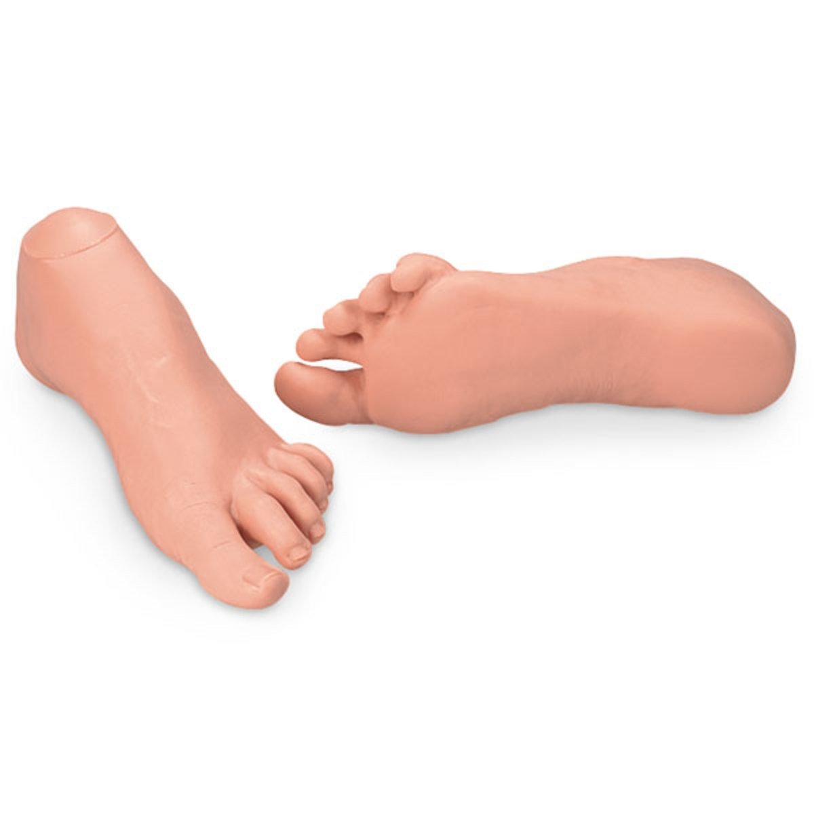
Image developed by universalmedicalinc.com

